Sturgeon Point Productions
Internship Guide
The Internship Program
Sturgeon Point Productions produces and markets educational videos. We started our company in 1968, and now we are a dynamic and creative independent film and commercial production company. From our base in Miami, we create both contract and in-house videos and feature films.
As an intern, you might take part in the following types of productions:
- Short feature films
- Documentaries
- Commercials
- Training films
- Sales and marketing videos
- Recordings of live concerts, sporting events, or theatrical productions
Here is a partial list of internship positions currently available:
- Production Assistant
- Assistant Director
- Assistant Camera Operator
- Assistant Makeup Artist
- Assistant Set Designer
Requirements
The exact requirements vary depending on the type of internship. Sturgeon Point Productions cooperates fully with local college film programs, and we draw our intern candidates from our list of participating colleges. All applicants must:
- Be enrolled in an accredited film program
- Be available during the entire production schedule
- Submit two faculty recommendation letters
All internships also require that you have completed at least some of the coursework in the appropriate field of study. For example, for an Assistant Camera Operator internship, you must provide evidence of completion of the basic video courses. Applicants for internships should plan to present samples of their work during the first interview.
Some internship positions will have additional requirements. For example, if film plans require travel to a foreign country, you must have a valid U.S. passport and any necessary inoculations. See the internship job description for specific information.
If you are currently enrolled in a film program in the Miami area, your internship may also make you eligible for college credit as independent study. See your program advisor for details.
Introduction to Upcoming Internships
Once a year, Sturgeon Point Productions conducts a series of meetings to announce and describe upcoming projects and internships. Our employees are available at these events to describe each internship opportunity and to answer your questions. Meetings take place in our studios and are open to all eligible students enrolled in local film programs. Here is a list of September meetings:
- Technical (camera, lighting, sound) September 4, 7:00 p.m., Studio B
- Artists (makeup, costume design) September 5, 6:00 p.m., Cafeteria
- Filming (directing and producing) September 6, 7:00 p.m., Studio A
- Art (set design, storyboards, illustrators) September 7, 6:00 p.m., Cafeteria
- Animation September 11, 7:00 p.m., Animation Lab
- Music September 12, 6:00 p.m., Cafeteria
- Video Editing September 10, 7:00 p.m., Cafeteria
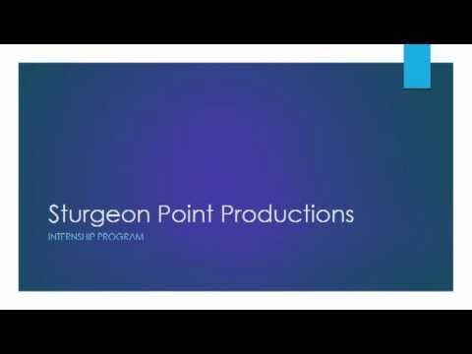
For more information and to sign up for our weekly newsletter, visit our website at www.sturgeonpointproductions.com. Be sure to view the following video to learn about some of the important skills you will develop as an intern with Sturgeon Point Productions.

